Apple Picking Algebra
Adapted From: http://insidemathematics.org/common-core-math-tasks/8th-grade/8-2005%20Picking%20Apples.pdf

Grade Level: 8th grade

Objective:By the end of the lesson, students will be able to solve the two variable equations and explain how they solved it.

Common Core Standard:
8.EE.8 Analyze and solve pairs of simultaneous linear equations.
b. Solve systems of two linear equations in two variables algebraically, and estimate
solutions by graphing the equations. Solve simple cases by inspection. For example,
3x + 2y = 5 and 3x+ 2y = 6 have no solution because 3x + 2y cannot simultaneously be 5 and
6.
c. Solve real‐world and mathematical problems leading to two linear equations in two
variables. For example, given coordinates for two pairs of points, determine whether the
line through the first pair of points intersects the line through the second pair.

Materials:
Apple Picking Algebra Problems

Procedure:
Introduction:
- Tell story: This weekend my friend and I wanted to go pick apples. She knew of a place called Pam’s Orchard but I had heard of a place called David’s Apple Orchard. We couldn’t agree which one to go to so we decided to do a little research to see which one what get us the most apples for our money. This is what we found.
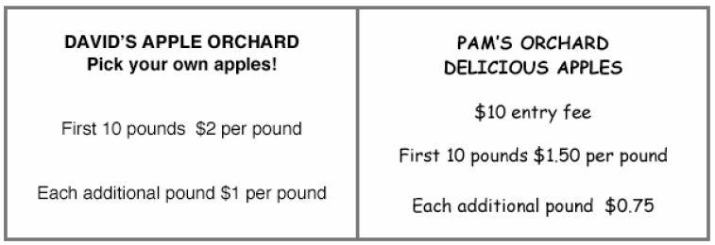

- We still didn’t know what to do so we were wondering if you could help us out?
Task:
Take a guess and write in your math journal: Which orchard will be cheaper if we want to buy 40 lbs of apples? Why do you think so? Don’t do any computations!

Students will work with a partner to solve the following problems. Make sure to stress showing your work!
- We want to buy 40 lbs of apples, how much will that cost at David’s Apple Orchard?
- How much would it cost to buy 40 lbs of apples at Pam’s Orchard?
- Which orchard should we go to?

Meet with another pair of students. Explain to the other pair what you got for an answer and how you did it.

Go back with your original partner and work on the following problems. Show your work!
- I have $30 to spend at the orchard.
o How many pounds of apples can I buy at David’s orchard?
o How many pounds of apples can I buy at Pam’s orchard?
- How many apples must I pick before I pick before Pam’s orchard is cheaper than David’s?

Closure:
Have partners answer the following questions to the class. Pick a few pairs per question.
- How many pounds of apples can I get for $30 at David’s orchard? How do you know?
- How many pounds of apples can I get for $30 at Pam’s orchard? How do you know?
- How many pounds of apples must I pick so that Pam’s orchard is cheaper than David’s? How can you tell?

Homework: You got $15 to spend on the field trip to the apple orchard. students will write a letter to the teacher telling them which orchard would be better to go to, why, and how they came up with their answer.

Assessment:
- Teacher will listen to the pairs explaining their solutions to others.
- Teacher will circulate the room and ask questions throughout the work period, recording data as they go.
- Teacher will read the letters the students wrote to make sure that students understand how to solve the problem and can explain it. The teacher will grade and return this letter but could also make a copy of each one and keep it as a student sample.
Differentiation:
Gearing Up:
- Bring in 20 lbs of apples and a scale. Have the students weigh the apples to find the weight and then determine how much that weight of apples would cost at each orchard.
- What if there was another orchard the next town over and their prices were the following:
Entry Fee: $5
Price for first 5 lbs: $2.50 per lb.
Each additional pound: $1.50 per lb.
Which of the 3 orchards will be cheaper if I want to buy 35 lbs?

Gearing Down:
- Present the information about the orchards separately. Do one orchard and ask the questions. Then, if there is time, ask the same questions with the second orchard. They may just not compare yet.
- Make the numbers smaller. Maybe it is $1 a lb at one orchard and a $5 entry fee and $0.75 a pound at the other and you only need 10 lbs of apples.

Justification:
This lesson is an example of teaching for understanding because it involved many of the things we’ve learned in class. Communication is a very important part of teaching for understanding and the students have many opportunities to communicate in the lesson. They get to work with a partner, then talk with another pair about their work, present their findings to the class and write a letter to the teacher arguing their position to a problem based on their calculations. This also brings in the practice standard of argumentation. They have to construct an argument to back up their math and then tell another group about it. Another practice standard that this lesson brings in is reasoning. The students have to reason quantitatively to what the prices represent for finding out a total. Also, the practice standard of problem solving is present. The students need to figure out what orchard would be cheapest and which one would give them the most apples for their money. The process standard of connections is also a part of this lesson. This task is very realistic since apple picking is so popular in the fall, so many children will most likely be able to relate to it. It also makes it relevant because a possible field trip is discussed.

