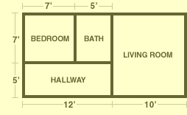

Directions: First use the area formula ( A = B x H ) to find the area of each of the rooms. Then pick which type of flooring you want in each room. (It does not have to be the same floor for each room.) Next calculate the price of that flooring for each of the rooms. Use the space provided after each room to show your work.

Type of Floor | Grey Carpet  $7 per sq. ft. | Brown Carpet  $5 per sq ft. | Hardwood  $10 per sq. ft. | Tile  $8 per sq. ft.

Bedroom
Dimensions:
Area:

Flooring Type:____________ Flooring Cost for Bedroom $_________

